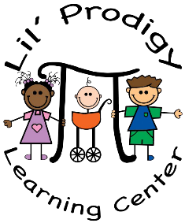

Policy on Technology and Use of Social Media

Social Media:
The posting of confidential and identifying information about the children, parents, or staff at the Center on social media (e.g., Facebook, MySpace, Twitter, etc.) is strictly prohibited. In no way does Lil Prodigy want to restrict the rights of its employees to engage in social media. However, when confidential information is written in a public forum, it may result in disciplinary action for the employee. The posting of non-confidential information (promotional materials and the like) shall be restricted until approved by the parents AND owners. This may include but are not limited too LPLC Facebook or website.

Pictures:
As with the use of social media, the publication of photos from the Center, whether online or otherwise, is generally prohibited without prior approval from the owners. In general, approval will usually be granted for pictures which promote the Center’s mission, demonstrate the educational achievements of the Center or the children in our care, or which otherwise portray the Center’s positive contributions to the community. Staff may take pictures of the activities in their classrooms to share with the families of the children in our care, as appropriate (to document a child’s progress, etc.). As mentioned previously, some families have chosen to restrict photograph permissions, and it is expected that all employees will abide by those wishes. These restrictions will be noted in the classroom binder.

E Mail/ Internet Use
Employees are not permitted to utilize Center computers or internet access for personal reasons, including email, web surfing, and other activities not related to the Center

